[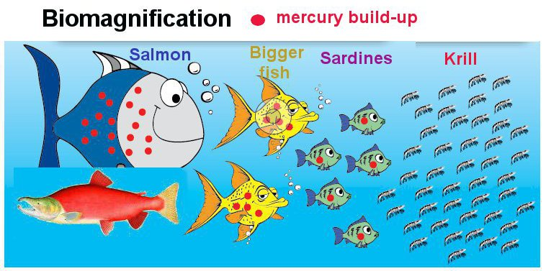](http://www.google.com.au/url?sa=i&rct=j&q=&esrc=s&frm=1&source=imgres&cd=&cad=rja&uact=8&ved=0ahUKEwjspoqAm8_PAhWHNJQKHQp6CMwQjRwIBw&url=http%3A%2F%2Fwww.freegrab.net%2FKrill%2520oil%2520benefits%2520good.htm&psig=AFQjCNEd9nDj_oLRvBP_YUXXzOvbWAS9IA&ust=1476153647540830)